What is ALE ?
ALE stands for Application Link Enabling. Application Link Enabling is a very common technology used in SAP to transfer master and transactional data between different Logical Systems. ALE is a proprietary SAP technology.

What is EDI ?
EDI stands for Electronic Data Interchange. EDI is a much older term and has been used in existence much before SAP. EDI is a generic technology that has been standardized using ANSI and EDIFACT standards. EDI is a very standard Industry standard used for business communication across partners.

What is IDOC ?
IDOC stands for Intermediary DOCument. IDOC is an SAP proprietary format for storing business data that needs to be communicated across systems. When we mean systems, this could be between multiple systems ( Both SAP as well as non-SAP systems).

What is the Difference between EDI & ALE ?
ALE is used for distributing large volumes of similar data between different Logical systems. For example, distributing customer master data between two SAP systems is easily done using ALE. Similarly, when invoices from the core SAP system needs to be transferred to a different non-SAP invoice processing system, ALE is used.

EDI is also used to communicate data between different logical systems. For ex., sending out invoices, or order acknowledgements to customers is a perfect example to use EDI. Similarly, we could use EDI to receive inbound orders from customers.

There is a general confusion that ALE is a technology to be used between different SAP systems and EDI is the technology to be used between SAP and non-SAP systems. While this is true statistically, in principle the difference is much more subtle.

EDI is used to communicate with Partner Systems, while ALE is used to communicate between Logical Systems. Please do however observe that a Partner System could also be a logical system.

Customization
Customization of ALE & EDI is pretty similar technically. Let's concentrate on ALE first.

[SALE] -> This is the transaction code used for ALE configuration
[WEDI] -> This is the transaction code used for ALE Development.

We will be doing all the customization in an ECC 6.0 IDES system. So, please get access to one before following along.

Logical System :
In SAP, a logical system means a client in an SAP instance. A logical system is just a label that needs to be assigned to a client in SAP. Goto [SALE]->Basic Setting->Logical Systems. Here is where you define logical systems and assign them to a client.
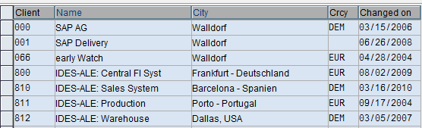
A shortcut to view the list of clients is [SCC4].

Let's pick client 800 (double click ) and as you can see, the name of the logical system is T90CLNT090. You can change it if you want to.
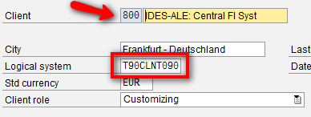

Similarly, there is another client 810. Now, lets try to establish master data communication between client 800 and client 810. (ie) between the two logical systems.
If a new logical system needs to be defined, it can be defined here. Each logical system needs to be assigned to a client.
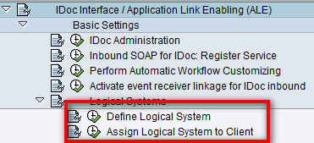

Configuration to be done on SENDER system

RFC Connection
RFC stands for Remote Function Call.SAP mandates that the name of the RFC destination should be the same as the logical system. An RFC connection provides a level of abstraction over the actual connection details between 2 different systems. In this case the communication should happen between client 800 and client 810 on the same SAP instance. We are now trying to create an RFC connection for client 810 on 800. This would require connection details ( IP Address ), client number and authentication details ( user id and password ). What we are essentially doing is establishing a conduit to another system.
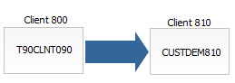
In this example, we are trying to establish an RFC connection between two clients on the same SAP instance. However, this procedure is same even if it is across different SAP instances.

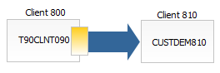
As you can see, there are different types of RFC connection. Without confusion ourselves further, lets just say, ABAP connections are used when the source and destination systems are SAP. TCP/IP connections are used when communicating with a non-SAP system.
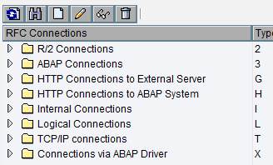
Let's try to create the RFC connection with the same name as the RFC destination - CUSTDEM810. ( In a standard SAP IDES system, this name could be different )

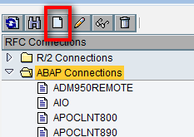
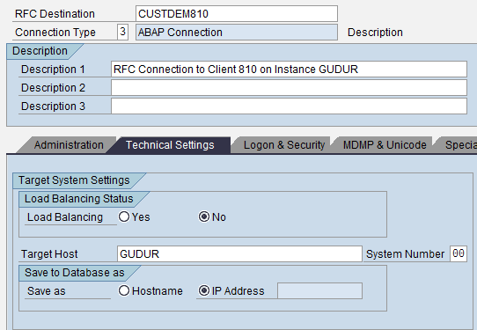

The system automatically picks up the IP address if the host is on the same subnet.
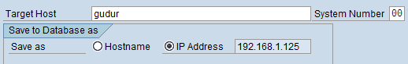

Enter the user id and password to test the RFC connection.
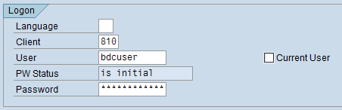

Cross Company Code
When transferring master data that has company code relevant data ( For example, the Finance view of the customer master data ), SAP mandates that we maintain a cross-company code. This is more of an SAP hack and might be taken away in the future.
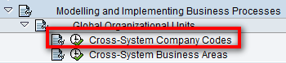

Define a new cross-system company code say "GL2300" -
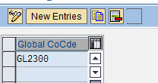
And follow further configuration to assign the company code to Chart of Accounts and actual company code.It is pretty self-explanatory.
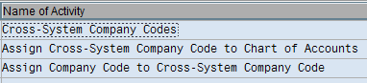

All of these functions can be handled in the menu path shown above. As discussed, these are just labels and do not have any controls.
Here is assigning cross-system company code GL2300 to company code 2300 and to INT chart of Accounts.
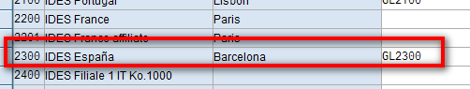
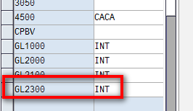

Distribution Model
A Distribution Model defines the following
- Sender Logical System
- Receiver Logical System
- Message Type ( logical Message type , Not the IDOC type )
Goto [BD64] , select the pencil button and click on "Create Model View". Enter a technical name and a short text.
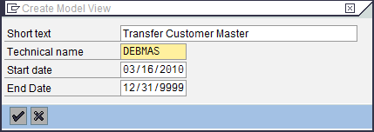

After generating the distribution model, goto Environment -> Generate Partner Profiles. Enter the name of the target logical system.
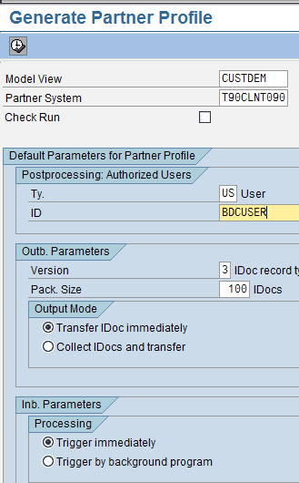

The log of the partner profiles will be generated. Sometimes SAP does not do this automatically and we might have to create the partner profiles manually.
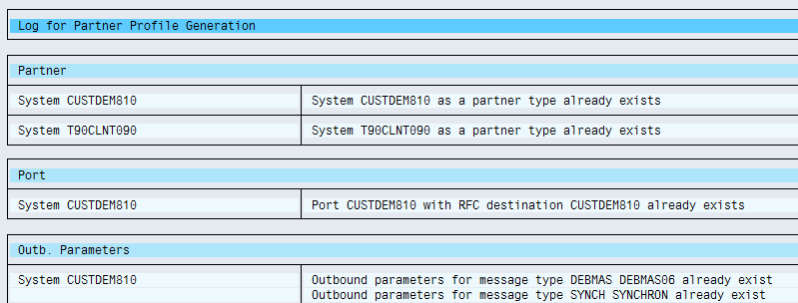

If you go to [WE20] you can see that SAP has generated partner profiles for us automatically based on the previous step. (Select Partner Type LS ).
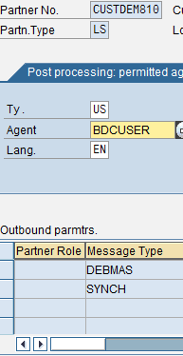

Pushing a Customer Through
Now lets push a customer through. Goto [BD12] (Tools -> ALE -> Master Data Distribution -> Cross Application -> Customer )
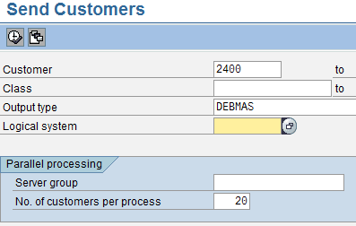

Enter a customer number, the output type ( DEBMAS in this case ). If you execute the system now, a master IDOC will be created and as many number of communication IDOCS will be created as there are distribution models set for the output type. If you select the right logical destination, only 1 communication IDOC will be generated.
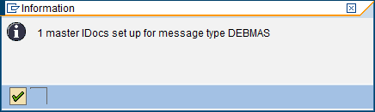

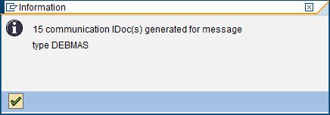

If you want to see the IDOC that has been processed, goto [WE02] and select the IDOCS created for today and sort by date to get the latest IDOC. As we can see from the green square, the IDOC has been processed successfully. If in case the IDOC has failed, use [BD87] to re-process the IDOC.

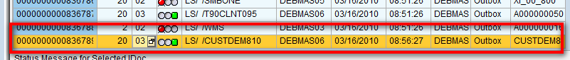

Now, in order to check the IDOC on the other logical system ( Client 810 in this case ) , log onto the client 810 and use [WE02] to look at the IDOCS in bound.

